Case 2-AFR-EGY-Akenaton-Head-Amarna-1351–1334 BCE

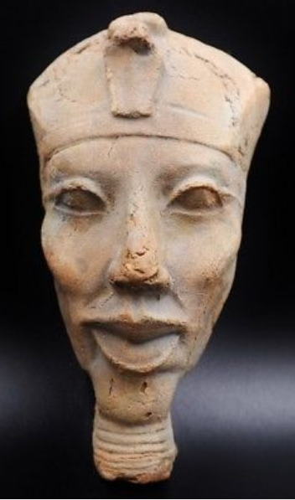

**Case No.: 2**

**Accession No.**

**Formal Label:**

**Display Description:**

This head of PharaohAmen-Hotep IV or Akhenaten (r. 1351–1334 BCE) may have been produced in conjunction with the colossi of this ruler at Karnac in the late Eighteenth Dynasty of the New Kingdom. In his early youth Akhenaten dedicated his reign to oppose "the selfish and the strong," priests whose chief deity was Amen or Amon (the first part of the pharaoh’s name). The allegiance of the priests was to their Amon cult and not to the Pharaoh, Amen-Hotep IV’s father, Amen-Hotep III. Amen-Hotep IV saw the tyranny behind the throne, and, before his own ascension to it, he began to develop a cult centered on Aten, perhaps suggested by his grandfather. Aten’s symbol was the solar disc, but Aten was not believed to be the material Sun: rather, He was regarded as the First Cause, a philosophical principle, one which harkened back to the unification of Egypt in the Old Kingdom when Ra, the Sun god, the unifying deity of the people.

Akhen-Aten IV ascended the throne with a passion to end the priestly tyranny and to make his kingdom "wise, and just.” In the face of strenuous Hittite military campaigns that were being waged against unruly Syrian princes in the north, Thebes received ominous reports of southward Hittite campaigns already advancing on Palestine.

In this age of turmoil, Amenhotep IV broke with the past in five significant ways.

First, he focused on the worship of a single First Cause, Aten. It was not unusual for an ascending Pharaoh to transfer the features of a reigning king to the image of a deity, to reflect in the statue of a deity the visual appearance of the sovereign. Akhenaten had these images commissioned in the way he wished to project himself. Consequently a series of ten colossi of Akhenaton were commissioned at Karnac. These colossi represented both the Father and the Mother of all that was created. Far from being sexless images of a ruler deity these colossi were powerful sexual forces encapsulated in the image of Akhenaten that could accomplish the generation of the Cosmos—a primeval god that incorporated the physiological characteristics of both sexes. Explicit sexual forces were responsible for the creation of the Cosmos. These were the forces that Akhenaten incorporated into his colossi at Karnac.

Secondly, he had a new city built -- Akhet-Aten, "Horizon of Aten," -- on the east bank of the Nile River, 312 miles south of the modern city of Cairo, in which a large temple to Aten and other ceremonial buildings associated with Aten worship were constructed. (In modern times this city has been known as Amarna for the Beni Amran tribe that lived in the vicinity when the first excavations were being initiated in the early 1900’s.)

Thirdly, henceforth no other Egyptian gods except the First Cause --Aten -- were permitted to be worshipped.

Fourthly, in Month 7, in the fifth year of his reign, he changed his name to Aken-Aten, “he who worships Aten,” and on day 13, Month 8, he entered Akhet-Aten, and vowed never to leave it.

Fifthly, the art style that was espoused in Akhet-Aten broke with the traditional Egyptian art style that had been the normative since the Old Kingdom with its rigid symmetry, blocky use of volumes for human subjects and strictly proportional volumes for human bodies. The Akhet-Aten art style (or Amarna art style as it is better known) dispensed with these conventions and substituted idiosyncrasies that can be seen in this sculpture of Aken-Aten’s head. It was sculpted probably by one of the élite sculptors who lived in the main city and not in the workmen’s precinct (Kemp 1987: 46). In this example we can see Aken-Aten’s distinctly elongated face with unusually large lips and prominent cheeks incorporating both male a female features that were essential to the iconography of the First Cause.

**Accession Number:**

**LC Classification: DT 73**

**Date or Time Horizon:** Dynasty 18, ca.1340 BCE

**Geographical Area:** Akhetaten (Amarna)

**Map:**

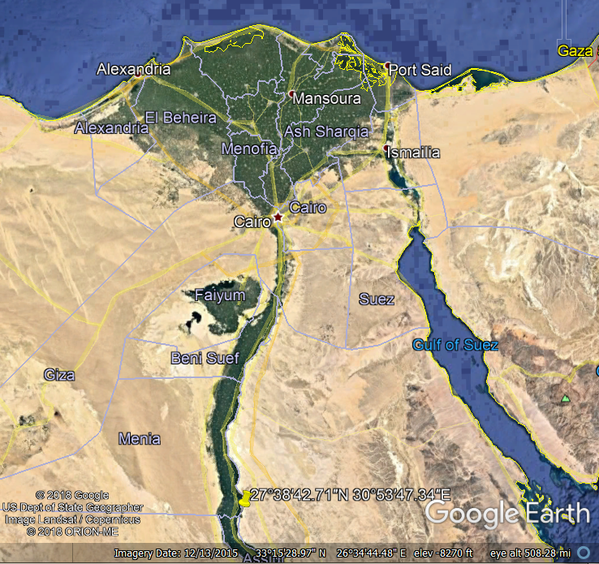

**Location of** Akhetaten (Amarna) **in Egypt.**



Akhetaten (Amarna) reconstruction by [Joan Lalucat and Adrià Turina](https://commons.wikimedia.org/w/index.php?title=User:Joan_lalucat&action=edit&redlink=1) in 2014 of the Escola d'Art del Treball. After https://upload.wikimedia.org/wikipedia/commons/thumb/f/f2/Amarna_2.jpg/1200px-Amarna_2.jpg

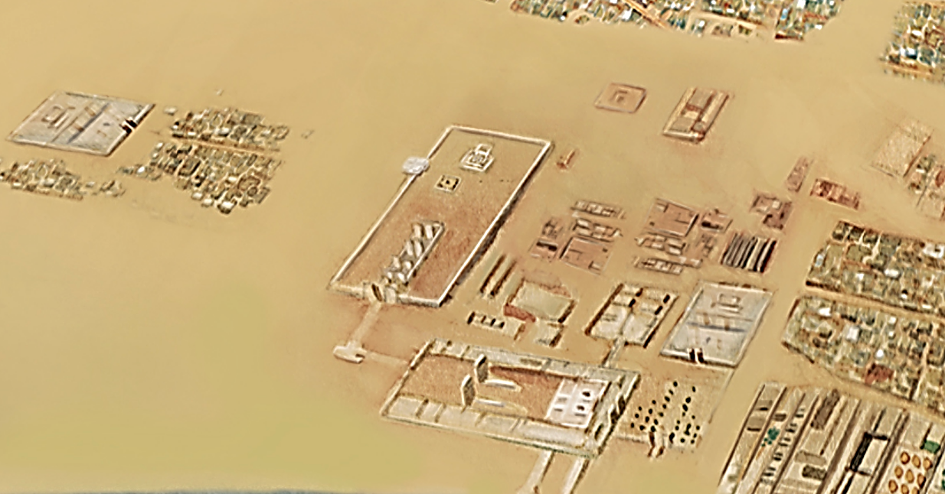

Akhetaten (Amarna) reconstruction by Joan Lalucat and Adrià Turina in 2014 of the Escola d'Art del Treball. After https://upload.wikimedia.org/wikipedia/commons/thumb/f/f2/Amarna_2.jpg/1200px-Amarna_2.jpg



**Map of** Akhetaten (Amarna), **the area around the Workmen's Village.**

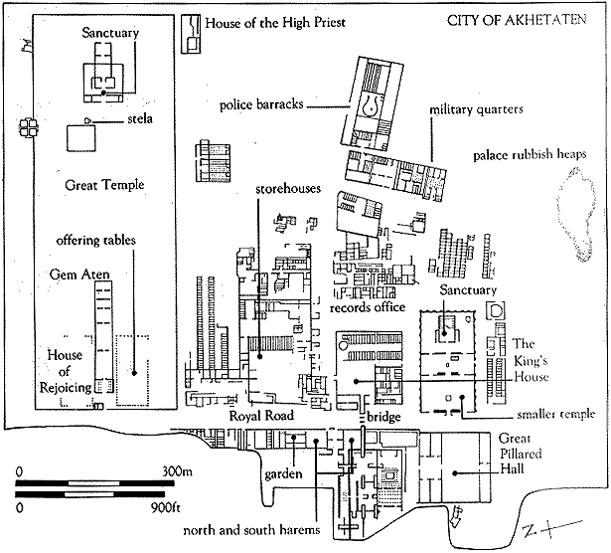

City of Akhetaten (Amarna) after http://www.newtowninstitute.org/newtowndata/NTimages/central_city_of_akhetaten.gif

**GPS coordinates:** [27°38′42.71″N 30°53′47.34″E](https://tools.wmflabs.org/geohack/geohack.php?pagename=Amarna&params=27_38_42.71_N_30_53_47.34_E_type:landmark)

**Cultural Affiliation:** original

**Media:**

**Dimensions:**

**Weight:**

**Provenance:**

**Discussion:**

Other characteristics of Akhenaten’s physiogamy include his exaggerated breasts, stomach, large hips and thighs that mirror the same feminine physiogamy as his wife.

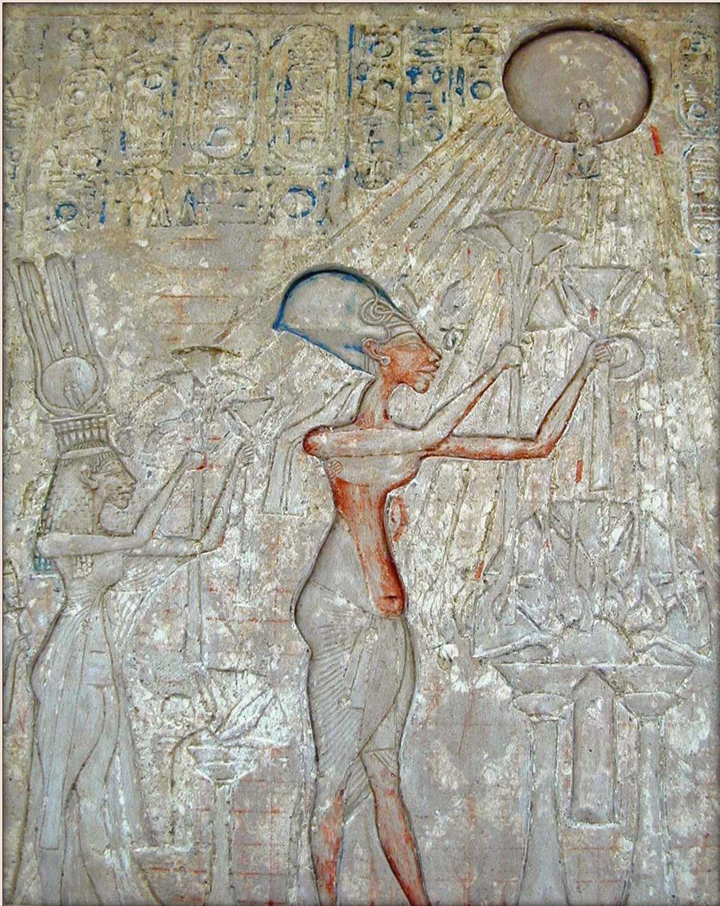

Pharaoh Akhenaten (center) and his wife, left, worshiping [Aten](https://en.wikipedia.org/wiki/Aten), whose rays emanate from the solar disk and terminate with hands. This panel is in the Akenaten room of the Cairo Museum. It was photographed by [Jean-Pierre Dalbéra](https://www.flickr.com/people/72746018@N00) from Paris, France, and <http://jdalbera.free.fr/thebes_2002_web/musee_caire/index1.htm>.

The following sculpture of Aken-Aten displays some of the same features in the face that is found in the sculpture of his head.

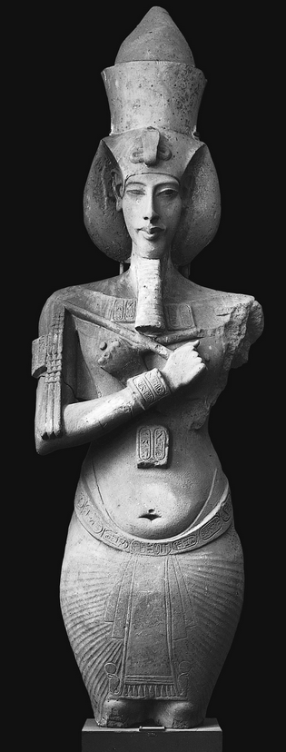 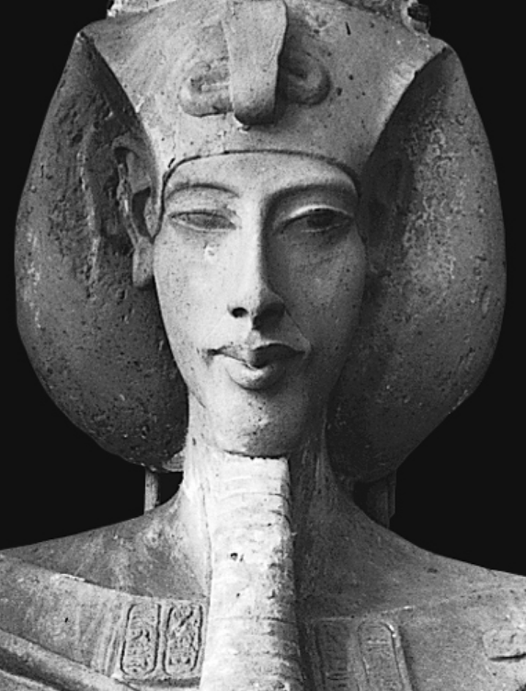

Aken-Aton in the Luxor Egyptian Museum after http://revelationnow.net/wp-content/gallery/akhenaten/akhenaten_hips.fw_.png

**References:**

Kemp, B.J., 1987. The Amarna Workmen's village in retrospect. *The Journal of Egyptian Archaeology*, *73*(1): 21-50.

Manniche, Lisa.2010. *The Akhenaten Colossi at Karnak*. Cairo, New York: The American University in Cairo Press.